**Around the World Pico Balloon**

8/27/18

Anika Williams

Bob Bruninga, WB4APR

Mission: This project uses a WB8ELK SkyTracker payload on a super-pressure 36” Mylar party balloon [[1]](http://www.wb8elk.com) to learn the engineering involved in flying a telemetry payload transmitting callsign, temperature, battery voltage, and location to be received via the worldwide APRS Satellite ground station packet radio network [[5]](http://aprs.org/). The balloon’s typical travel time around the world is about 2 weeks and can rise to nearly 40,000 ft in altitude for a specialized scientific balloon, or about 23,000ft for the Mylar balloon. The SkyTracker’s main components are solar panels, a GPS, CPU, and a 20 mW transmitter [[3]](http://gmigliarini.wixsite.com/wb8elk).

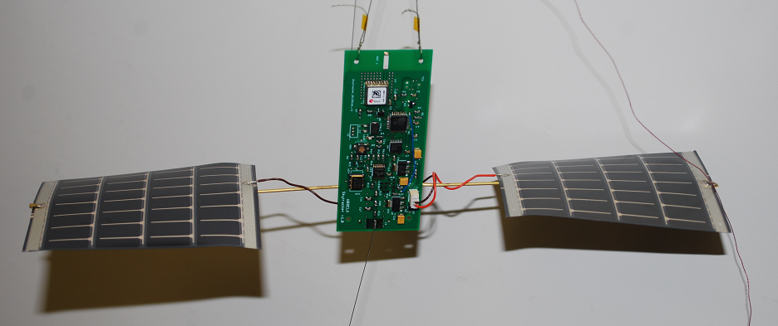  
Figure. 1. WB8ELK’s Skytracker GPS tracker device attached to solar panels and a guitar string antenna

**Description:** A super-pressure, constant altitude balloon is needed to hover in the polar jet stream, for at least two weeks. The payload will transmit periodically to minimize power and assure a high probability of ground stations receiving the signal and injecting the location into the APRS – Internet System (APRS-IS) where it can be seen on the web page, APRS.fi. Polar jet streams typically reside at an altitude of 30,000ft and 33,000ft, however, occasionally they dip to an altitude of 20,000ft.. Here is a detailed list of the mission’s requirements.

System Requirements: Altitude up to 30,000ft, duration of at least 15 days

Power Subsystem: 150mW of power (4.86V with 31mA current drain)

Transmitter: 25mW of output power

Solar Power: 180mW (3.6V with 50mA)

Balloon: Shall deflate at no more than 0.005238m3/day

Survivability: Withstand +/-90 F and up to 2.34 liters of rainfall per ft2

**Analysis:** For long duration balloons, the following variables are used:

**Constant Altitude Float Objective:** To calculate the payload to achieve a 1:1 buoyancy to gravitational force ratio the following other values and equations are needed.

Ground elevation pressure Ideal Gas Law: ,

Flight elevation pressure Ideal Gas Law:

Temperature Change Equation:

Density Equation:

Buoyant Equation:

Number of Helium moles to reach its full balloon volume:

This translates to grams of Helium. Using this formula:

Since the number of Helium moles in the balloon is constant, we can solve the gas law equations for the initial volume of the balloon at sea level:

Multiplying this initial volume by the air density at ground level gives the total mass the balloon can lift initially to reach the desired height.

The gravitational force must equal the buoyant force at flight level:

and

Setting the two equal gives:

The g’s cancel out leaving the mass in kg: where

Solving for m gives a 36g maximum lift mass for a Mylar balloon at 20,000ft. We can subtract the mass of the balloon (38.5g), the helium, and all the other glue, string, tape, payload, solar panels, etc., to then find the mass of the payload. By 25,000ft the Mylar balloon would only be able to lift its own weight and 2 more grams. Solving for the maximum payload mass of an SBS-13 scientific balloon at 30,000ft is 23g, and by 40,000ft the balloon has no lift mass.

Since we know the mass of the Skytracker to be 12g, we can work backward and find the air density, which then correlates to an altitude. The air density it can reach is 0.65kg/m3 which correlates to an altitude of nearly 23,000ft for the party balloon. For the SBS-13 scientific balloon, the highest altitude it can reach with a 12g payload is around 32,000ft.

**Speed and Tracking**: The party balloon deflation rate of nearly 0.005238m3/day can last between 3-5 weeks, depending on flight stress. This yields a decrease in altitude of about 1,500ft/day using the following formula.

where *V* is the balloon volume and ***t*** is the time to deflate

The speed at which the balloon will travel around the world is calculated using the minimum and maximum wind speeds if caught in a jet stream, and average wind speeds if not captured by a jet stream. The balloon will travel at the same speed as the wind.

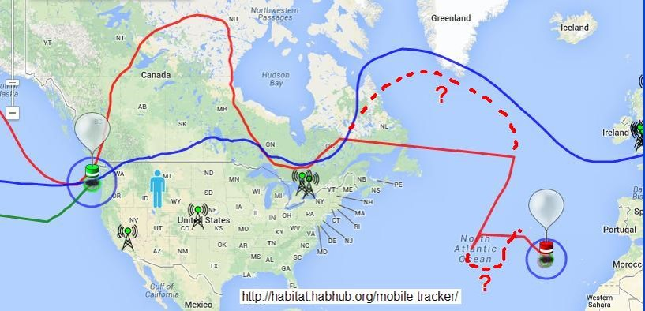  
Figure. 2. Above shows the path of M0XER’s balloon path. As you can see, it does not follow a straight line.

The balloon will travel at lower speeds (65km/hr) if not caught in a jet stream. As shown in figure 2, if a balloon follows the jet stream it will often takes a significantly serpentine path around the Earth. To predict the upper limit of the added distances compared to the basic circumference at the given latitude, we assume a semicircular path which would be pi/2 times larger than a straight path.

When out of range of ground stations, the APRS system plots a straight line between known points. On figure 2 we have drawn a dotted line to estimate the actual track of the M0XER[[4]](http://leobodnar.com/balloons/)balloon (red). Some balloons (blue) make up for this lack of ground station data by always storing a copy of its historical data combined with real-time data so that when the payload is over a ground station then the historical data, can be mapped simultaneously with the real-time data to rebuild non-received data.

The jet stream path could take a little more than a month to travel around the world in the worst-case scenario, and only if a balloon can reach around 38,000’ or so. But Mylar balloons only last 3-5 weeks, so this mission cannot make the entire flight.

The next calculations give the approximate distance, and time the balloon will take to travel around the world. Essentially, there is a race between the speed of the balloon and its deflation rate.

Calculation Table #1: Balloon Estimations

|  |  |  |  |  |  |  |  |  |  |
| --- | --- | --- | --- | --- | --- | --- | --- | --- | --- |
| Highest Altitude (ft) | Wind Speed (km/hr) | | | Days until it reaches ground | Payload Mass (g) | Total Mass (g) | Days until it would reach around world | | |
| 20,000 (Party) | 65 | 80 | 400 | 13 | 36 | 100 | 22 | 18 | 3.5 |
| 21,000 (Party) | 14 | 24 | 86 |
| 23,000 (Party) | 15 | 12 | 72 |
| 25,000 (Party) | 17 | 0 | 57 |
| 32,000 (SBS) | 21 | 12 | 174 |
| 35,000 (SBS) | 23 | 6 | 159 |
| 40,000 (SBS) | 27 | 0 | 145 |

If the wind speeds are 80km/hr-400km/hr, the time interval it would take to complete a tour around the Earth’s circumference (40030km) is about 14.5±7.5 days.

**Power Consumption:** The Skytracker has a 25mW RF transmitter and comes with solar panels and an optional 3 cell AAA lithium battery pack. The battery is only needed if tracking at night is desired. Otherwise the solar panels can provide ample power during high sun angles. Most of the power is used for the GPS unit and APRS processor. The transmit duty cycle of the device is two packet transmissions (about 1 second each) every 2 minutes, this is to maximize the probability of contacting a ground station. This means, it will transmit its location close to 360 times per day, since at night without a battery it will be incapable of transmitting data. The solar panels will produce about 180mW of power each, while the average power drainage is about 150mW.

**Telemetry:** The GPS data will be formatted into a conventional Lat/Long APRS position format including course and speed. The data will also add additional temperature and voltage telemetry in the APRS base91 format for automatic parsing by ground stations.

An example of the APRS format as captured on the APRS-IS (http://pcsat.findu.com):

“2017-10-06 12:18:20 EDT: W6SUN-4>APELK0,WIDE2-1,qAR,AG6IF-1:!3253.98N/11656.35WO095/024/A=023980 10 4.86 -5 7309 40 |!I&@#w!+!"!"| ”

Where “2017-10-06 12:18:20 EDT” is the time stamp added by the ground station.

The “W6SUN-4>APELK0,WIDE2-1,qAR,AG6IF-1 is that APRS path information.

The “:!3253.98N” is latitude and “11656.35W” is longitude and “O095/024” is course and speed

The altitude in feet is the “A=023980” and all remaining is the APRS commend field.

The “10” is the number of GPS satellites and “4.86” is the solar panel voltage

The “-5” is the temperature in ℃, “7309” is the altitude in meters, “40” is the sequence number, And finally “ |!I&@#w!+!"!"| “ is telemetry in APRS’s base91’s format:

Converted to digit pairs |ss1122334455!|gives the sequence number and 5 telemetry channels

Since these world balloons cover multiple continents, the CPU uses geo-fencing limits to know what APRS frequency to use. The APRS national frequency in the U.S.is 144.390MHz , Europe is 144.800MHz, and Australia is 145.715MHz. Over the U.S., the Skytracker also transmits duplicate data 10 seconds later on the detected balloon-only channel of 144.340MHz.

**Testing:** The Skytracker came with simple instructions on how to engineer the parts together and tie the delicate system to the balloon. To test, the balloon must be outdoors and receive a valid 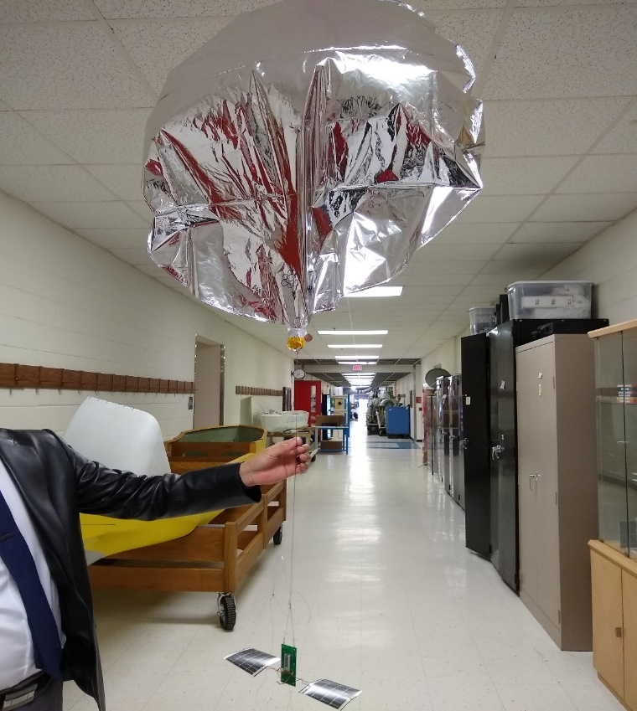GPS signal. Inside, it will only display the red LED which flashed “hi” in Morse code. The system current was verified with a bench supply set to 4.5 volts.

**Filling the Balloon:** To fill the 36” Mylar balloon with the correct amount of helium, we inserted a 12” white straw-like tube into the opening of the balloon. The 12” length is needed to get past the self-sealing neck of the balloon. Then we attached a weight onto the balloon that along with the white tube weighed 3 grams more than the Skytracker. We filled the balloon until it was neutrally buoyant with the test mass, then took out the tube and unhooked the test mass and taped the balloon filling hole shut. We attached the Skytracker to the balloon with a fishing swivel. To verify the 3g free lift, we taped a nickel (5g) and verified the balloon sank. Then tried a penny (2g) and the balloon rose, thus verifying we had about 3g of free lift.

Figure 3 shows the Skytracker and balloon prepared for flight.

We launched the balloon outside on a sunny day on 8/13/2018 at 9:41:21am EDT.



Figure. 4 shows the balloon rising into the sky clear of nearby light poles.

The launch video can be seen at:

http://aprs.org/balloons/Balloon2018/Pico-Anika-summer/Pico-baloon-launch-aug2018.mp4

**Tracking and Data**: All of the data from APRS.FI was pasted into Notepad so we could remove all extraneous non-telemetry and duplicate packets. Then the telemetry was imported into Excel selecting delimited format to align all the columns. Then we converted the time stamps into seconds, and graphed it with altitude. The graph in Figure 5 shows that the early altitude increased and steadily approached a constant value of about 27,000 ft. .

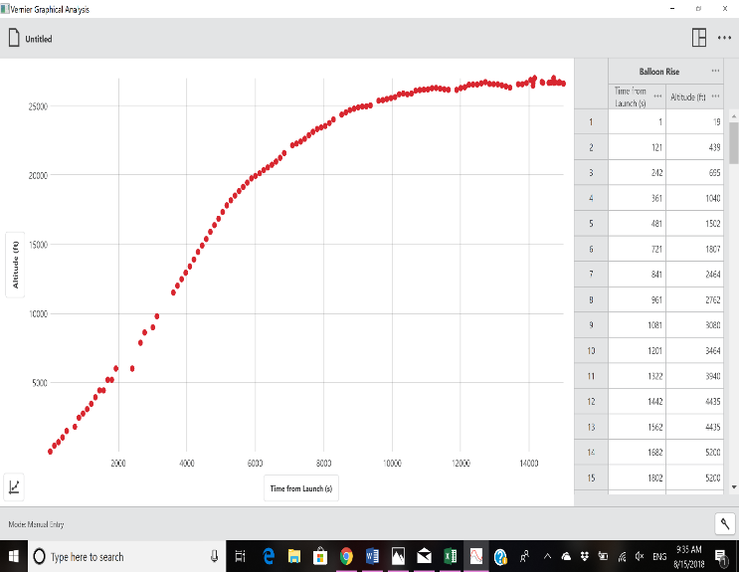

Figure 5. Plot of altitude over time, stabilized at around 27,000 feet as expected

There were variations and the highest altitude reached during the flight was 30,506 ft, but the average was around 28,000ft, the lowest temperature was reported at 8℃, the highest voltage recorded was 6.34V, the average number of GPS satellites being tracked by the payload was about 10, and the transmitting frequency stayed the same at 144.390MHz and 144.340MHz since unfortunately, the balloon never left the United States as shown in Figure 6.

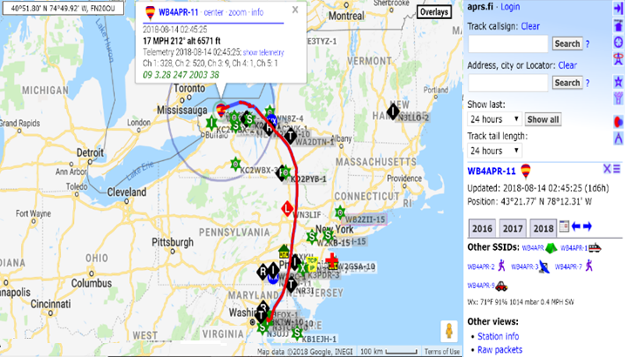

Figure 6. Total flight path as captured on APRS.FI was very unusually for this area, since most balloons launched from the East Coast go immediately to the Atlantic Ocean.

**The Descent:** The last data point,

“2018-08-14 02:45:25 EDT: [WB4APR-11](https://aprs.fi/?c=raw&limit=&call=WB4APR-11)>APELK0,[K2GC-1*](http://aprs.fi/?c=raw&limit=&call=K2GC-1),qAR,[WD8CIV-3](http://aprs.fi/?c=raw&limit=&call=WD8CIV-3):!4321.77N/07812.31WO212/015/A=006571 09 3.28 247 2003 38 |!G$X&b!*!"!"| “

was received at 2:45:25 am EDT the next morning 08/14/2018. The balloon was over Carlton, New York, at an altitude of 6571 ft, and traveling at 17mi/hr (27km/hr). To predict when the balloon was to land, we plotted the altitude of the final 5 hours of flight as shown in Figure 7.

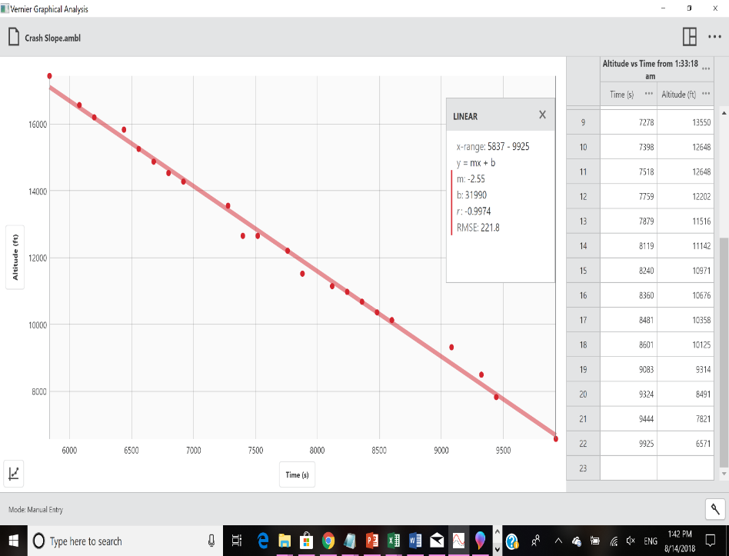

Figure 7. Altitude vs Time of Descent Interval

The balloon flew for a total of 17 hours and 47 minutes. Based on the slope of this graph we can predict where the balloon probably landed after the last telemetry point. Time in seconds from the starting point of descent at 01:33:18am is on the x-axis, and the altitude of the balloon is on the y-axis. Following this linear descent to intersect with the ground at 243 feet, the balloon was predicted to land around 3:28am.

Extending this time with the last know course and speed we were able to predict ground contact about 11.5 mile (18.5 km) further south as shown in Figure 8.

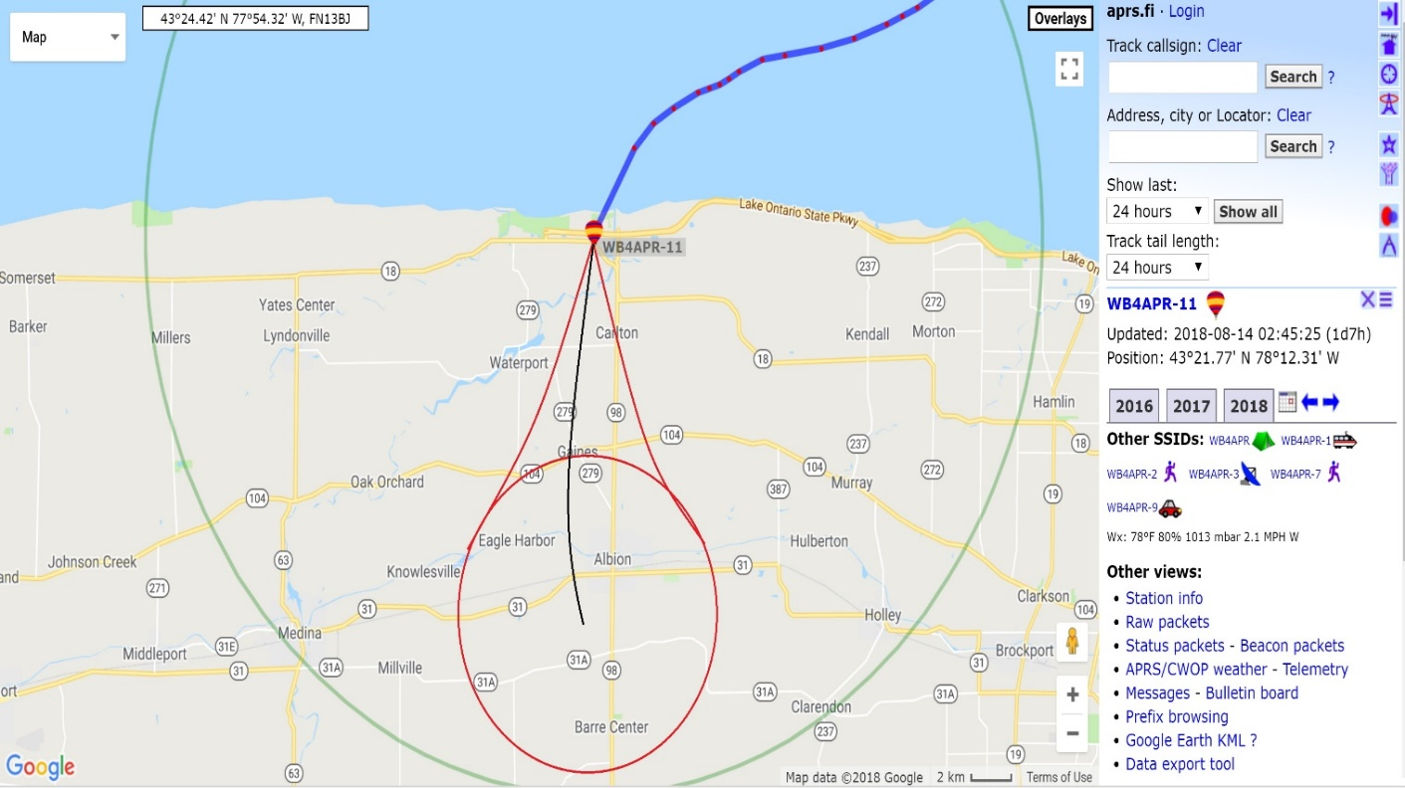Fig. 8 shows the predicted landing area of the balloon.

There were significant storms near Lake Ontario between the hours of 12am and 3am. The weather turbulence at 23,000ft seems to have been severe enough to stress the balloon and cause a leak. Clearly this shows the risk of attempting long duration constant pressure flights with the altitude limitations of Mylar party balloons ($3). The higher scientific SBS-13 balloon may have been above this storm.

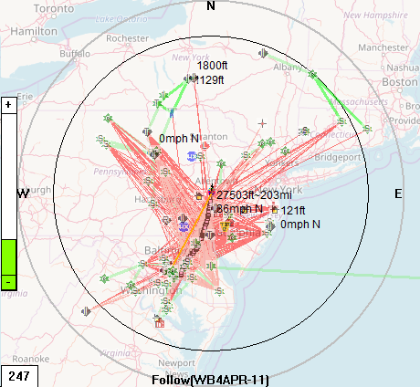

Figure. 9 shows all the ground station links that received valid Skytracker signals.

Although the transmitter of this balloon is only 25 milliwatts or about 0.05% of the power of a typical 50 Watt APRS mobile, the plot in Figure 9 shows the theoretical slant range to the Earth’s horizon from the height of the balloon out to the predicted 200 mile limit at that altitude shown by the black circle. The red ray-traces show that ground stations all the way out to that edge received data directly.

**Conclusion:** The project’s goal was to learn the engineering involved in flying a telemetry payload to high altitudes on a helium filled constant pressure balloon. This was accomplished using the WB9ELK Skytracker module attached to a 36” Mylar balloon. The balloon was intended to fly around the world in about 2 weeks if it got captured in a polar jet stream at around 25,000ft and did not experience any severe weather. But at this altitude, the “Around the World Pico Balloon” didn’t quite make it due very unusual wind directions on the first day taking it almost due North instead of East and due to weather complications on the first night. But the flight was entirely successful in providing telemetry and a flight altitude completely as predicted.

References

[1] Brown, W. (n.d.). WB8ELK Balloons. Retrieved from <http://www.wb8elk.com/>

[2] Brown, W. (n.d.). *Around the World in 14 Days* [Scholarly project]. In *Huntsville Amateur*

*Radio Club*. Retrieved from <http://www.harc.net/programs/wb8elk-balloon-tracking.pdf>

[3] Pico Tracker for High Altitude Ballooning. (n.d.). Retrieved from

<http://gmigliarini.wixsite.com/wb8elk>

[4] Bodnar, L. (n.d.). Balloon Flights. Retrieved from <http://leobodnar.com/balloons/>

[5] Bruninga, B. (n.d.). APRS: Automatic Packet Reporting System. Retrieved from

<http://aprs.org/>